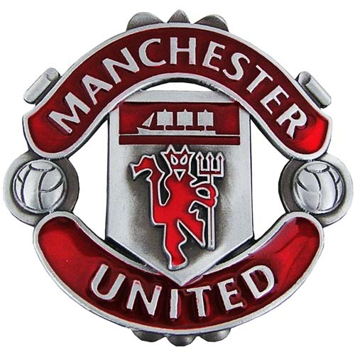

- Where and when will the team play?
The will play at the soccer stadium and they play doing the soccer sesame.
- Who are some of the key players?
Wayne Rooney he is the baste player.
- What are the team's strengths?
Will the Bing playing for long time and they are good player and they are top soccer player in the ward.
- Why should the public come to watch them?
Will I like the time sans I was 10 years old I all wise want to go and see theme

